CONFIDENTIAL PATIENT INFORMATION
Patient Name:_______________________________________ Birthdate:_________________ Sex: M/F
Address:_______________________________________ City: _____________ State:______ Zip: _______
Home ph#:____________________Work#: _________________Cell#:______________________________
Age:______ SS#:_______________ Email:____________________________
Married Single Widow Other Spouse Name:_________________ Ages of Children_____________
Occupation: _______________________________ Employers Name: ________________________________
How did you hear about us?  Family  Friend  Google  Yelp Facebook  Doctor  Therapist  Event
Referred by: _________________________
Insurance:  HMSA  Kaiser  Medicare  UHA  HMAA  VA Other _____________
Do you have insurance that covers chiropractic? Yes No Unsure PPO plan HMO plan (requires referral)
Name of Insurance: ________________________ Policy Number: ____________Group #: ________ Policy Holder’s DOB: ________
Subscriber Name: __________________________Relationship: ______________Primary Care Physician______________________
2ndHealthPlan Name: _______________________ Member ID#: ________________________Group #_________________________
Is your condition due to an Auto Accident?  Yes  No Work Related?  Yes  No
Are you employed by the City & County or State?  Yes  No
Have you had Chiropractic before?  Yes  No. If yes, where and when?________________________________
Have you had Massage Therapy before?  Yes  No. If yes, where and when?___________________________

Current Symptoms or Complaints
Please list reasons for this visit:  1. | Date first noticed | Please circle severity of symptom.  0 = none and 10= Severe  0 1 2 3 4 5 6 7 8 9 10 | Please circle how often this symptom  is present:  0-25% 26-50% 51-75% 76-100%
2. |  | 0 1 2 3 4 5 6 7 8 9 10 | 0-25% 26-50% 51-75% 76-100%
3. |  | 0 1 2 3 4 5 6 7 8 9 10 | 0-25% 26-50% 51-75% 76-100%
How problem(s) began: _________________________________________ Please Mark Areas of Complaints
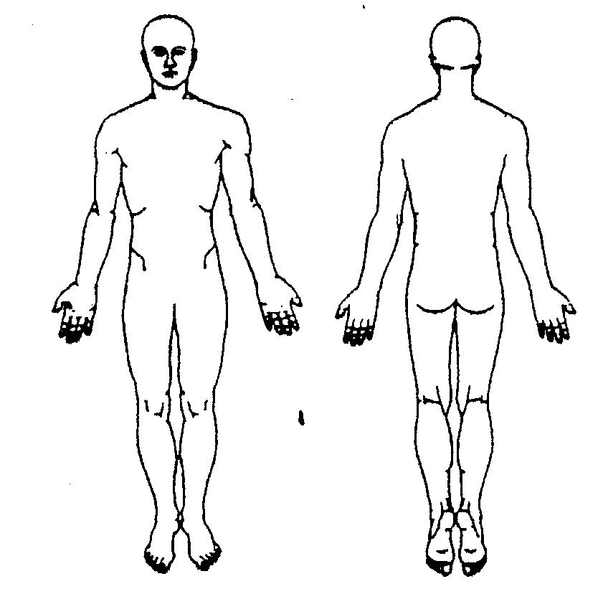
Is it getting:  Better  Worse  Staying the same
In the past week, how much has your pain interfered with:
Sleep | 0 = no interference 10 = severely limits  0 1 2 3 4 5 6 7 8 9 10
Work | 0 1 2 3 4 5 6 7 8 9 10
Exercise/Sports | 0 1 2 3 4 5 6 7 8 9 10
Household chores | 0 1 2 3 4 5 6 7 8 9 10
Other _______________ | 0 1 2 3 4 5 6 7 8 9 10
What time of the day do you feel worse? ____________________________
What types of exercises do you do? ________________________________
What kinds of therapy have you tried? ______________________________
Most comfortable sleeping position?  Side  Stomach  Back
Main hobbies and sports? ___________________________________
Have you had spinal X-rays, MRI, CT scan for your area(s) of complaint?  Yes  No

Dates(s) taken:_________________________ What areas were taken? ________________________________________

Please check all of the following that apply to you:

 Recent Fever

 Diabetes

 High Blood Pressure

 Stroke (date)___________

 Corticosteroid Use (cortisone, prednisone, etc.)

 Taking Birth Control Pills

 Dizziness/Fainting

 Numbness in Groin/Buttocks

 Cancer/Tumor (explain____________________

______________________________________

 Osteoporosis

 Epilepsy/Seizures

 Other Health Problems (explain)_____________ _________________________________________

 Prostate Problems

 Menstrual Problems

 Urinary Problems

 Currently Pregnant, # of weeks _______

 Abnormal Weight Gain Loss

 Marked Morning Pain/Stiffness

 Pain Unrelieved by Position or Rest

 Pain at Night

 Visual Disturbances

 Surgeries________________________________________ ____________________________________________________________________________________________________

 Medications___________________________________

_____________________________________________
Family History:  Cancer  Diabetes  High Blood Pressure
 Heart Problems/Stroke  Rheumatoid Arthritis  Other ___________
Current Health Habits:
Yes No Yes No

  Do you have good posture?
  Did/do you smoke?
  Did/do you drink alcohol?
  Do you eat healthy?
  Do you take supplements?
  Do you exercise regularly?
  Did/do you have occupational stress?
  High level of physical stress?
  High level of mental stress?
Have you been in any accidents? If yes, how many?____
What type(s) of service do you desire?
 Temporary relief of symptoms/pain control
 Elimination of cause of problem, if possible
 Maintenance/regular care to help maintain good health
Insurance Certification: I certify that the above information is complete and accurate. If the health plan information is not accurate, or if I am not eligible to receive a health care benefit through this provider, I understand that I am liable for all charges for services received. I agree to notify this doctor immediately whenever I have changes in my health condition or health plan coverage in the future. I understand that a quote of benefits is NOT a guarantee of payment and benefits are subject to change at any time. I understand that co-payments are to be paid at time of service._________ (INITIAL)
I understand that my chiropractor or Clinical Services Manager may need to contact my Primary Care Physician if my conditions need to be co-managed. Therefore, I give authorization to my chiropractor to contact my physician, if necessary. _________ (INITIAL)

I have reviewed and agree to the Insurance Limitations Forms. _________ (INITIAL)

I have reviewed and agree to the Open Ceiling and Privacy Information Forms. _________ (INITIAL)

I have reviewed and agree to the Arbitration Agreement Form. ________ (INITIAL)

For the safety and security of your account, we will be taking your photo. This will help prevent fraudulent activities and help us to identify our patient. Please initial here, allowing us to take your photo. __________ (INITIAL)

I understand that this clinic has a 24 Hour Cancellation Policy and that I may be charged a $25 fee for any appointments that are either missed or canceled without 24 hours notice. __________ (INITIAL)
Consent for Chiropractic: I hereby request and consent to chiropractic adjustments and/or other chiropractic procedures by Dr. Tyler Ryan, DC and/or anyone working in this office authorized by him to perform such. I understand and am informed that, as in the practice of medicine and all healthcare, the practice of chiropractic carries some risks to treatment. The most common risks are temporary aggravation of my condition or soreness. Rarer risks include, but are not limited to, fractures, strokes, dislocations, sprains, burns and aggravation of disc injuries. I do not expect the chiropractor to be able to anticipate and explain all risks and complications. I understand that results are not guaranteed. Further, I wish to rely on the chiropractor to exercise judgment during the course of the procedure which the chiropractor deems are in my best interests at the time, based upon the facts then known. I hereby give my consent for treatment.

Patient PRINT Name ________________________________________________________

Patient (or Guardian) Signature ______________________________________________ Date_______________

